Brian Johnson 12/9/11 Period 5 Carrer Exploration Report

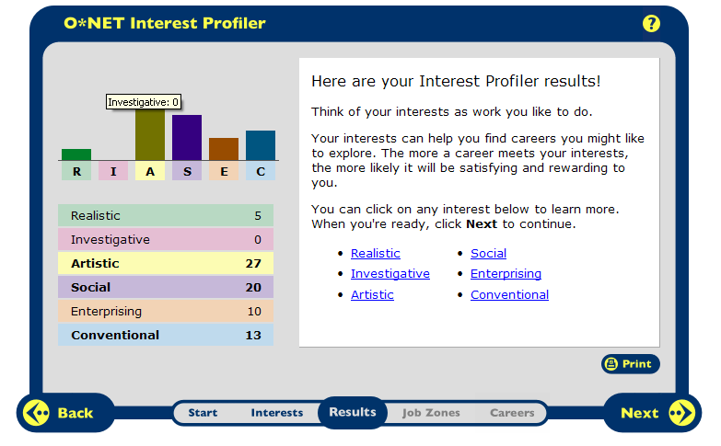

Artistic is accurate in my wants for my future career. An artistic person is either art related or music related. I love music and composing, etc… The field for Artistic is a Music Director or Arranger, which is what I would like to do in the future.
Social is also accurate in my wants for a future career. A social person is in the field of teaching children or anyone, which I have done all my life to my brother and peers in my classes. Social people can go into the field of School Teachers.

8 Specific Careers:
- Music Director
- Musician
- Music Arranger/Composer
- School/Music Teacher
- Teacher Assistant
- Secretary or Administrative Assistant
- Instructional Coordinator
- Education Administrators
Social ClusterArtistic ClusterConventional Cluster
HR1. What is the definition of each occupation that your group has chosen and the nature of the work?
- Music Director - Conduct, direct, plan, and lead instrumental or vocal performances by musical groups, such as orchestras, bands, choirs, and glee clubs. Includes: arrangers, composers, choral directors, and orchestrators. They can either teach in schools or write scores and music, or both.
- Musician - Practice musical instrument performances, individually or in rehearsal with other musicians, to master individual pieces of music and to maintain and improve skills.
- Music Arranger/Composer - Apply elements of music theory to create musical and tonal structures, including harmonies and melodies.
- School/Music Teacher – Teachers help and teach students concepts and subject, for example Math, English, and also life skills.
- Teacher Assistant – To provide help and assistance to the teacher, whether it be putting the lesson out on the desks, help clean up after class, etc…
- Secretary or Administrative Assistant – They serve as information and communication managers for an office; plan and schedule meetings and appointments; organize and maintain paper and electronic files; manage projects; conduct research; and disseminate information by using the telephone, mail services, Web sites, and e-mail. They may also handle travel and guest arrangements.
- Instructional Coordinator - Instructional coordinators play a large role in improving the quality of education in the classroom. They evaluate how well a school or training program's curriculum, or plan of study, meets students' needs.
- Education Administrators – To Plan, direct, or coordinate the academic, administrative, or auxiliary activities of public or private elementary or secondary level schools.

HR2. What are some of the related occupational fields?
- Music Director - Teachers, Band/Choral/Orchestra Directors, Composers and Arrangers
- Musician - Performing to the public, sometimes are private lesson teachers
- Music Arranger/Composer – Arranging/composing for film scores or for an individual
- School/Music Teacher – Public/Private schools, Elementary school teacher, Middle school teacher, High school teacher. Also pre-school teachers
- Teacher Assistant – Supervise out-of-school activities, assistant to a teacher, help teach a student, and communicating with others
- Secretary or Administrative Assistant – Clerical tasks, memos, prepare agenda’s, arrange meetings, etc…
- Instructional Coordinator – Department Head, teaching teachers and students
- Education Administrators – Principals, Assistant Principals, Deans, Administrators

HR3. Which personality type(s) is best suited to the occupations/jobs you have researched?
- Music Director - Artistic and Social
- Musician - Artistic and Enterprising
- Music Arranger/Composer - Artistic and Enterprising
- School/Music Teacher – Social, Artistic, Enterprising
- Teacher Assistant – Social and Conventional
- Secretary or Administrative Assistant – Conventional and Enterprising
- Instructional Coordinator – Social, Investigative, and Enterprising
- Education Administrators – Enterprising, Social, Conventional

HR4. What kind of education, training and qualifications are required?
- Music Director - Four-year bachelor's degree or higher of Music
- Musician - Needs prior knowledge of music and at least an associate's degree.
- Music Arranger/Composer - Needs prior knowledge of music and at least a Bachelor's degree
- School/Music Teacher – A bachelor’s degree from a teacher education program and a license. Private schools don’t require a license. Lower grades are less demanding knowledge but of all subjects, as in the higher grades you are focusing on one or two subjects.
- Teacher Assistant – At least some college classes, usually you start teacher assistants during your 3rd year of college
- Secretary or Administrative Assistant – High school graduates students who have an Office experience, also college degrees in business or industry.
- Instructional Coordinator – Have a Masters Degree in the field of the subject
- Education Administrators – Have a Masters Degree in the field of the subject

HR5. What technology skills are needed to be successful in the career/occupational fields you have explored?
- Music Director – Need to know how to use software like Finale and music notation software.
- Musician – Work with notation software, be in contact with people and such
- Music Arranger/Composer - Needs to know how to use Music notation software, and contact with others
- School/Music Teacher – Computers are an important role, education software, the internet, word documents, also e-mail with parents.
- Teacher Assistant – Same as the school/music teacher.
- Secretary or Administrative Assistant – Should be proficient with typing on word documents.
- Instructional Coordinator – Computers, spreadsheets, word documents
- Education Administrators –familiarity with computer technology like word documents and e-mail with teachers and parents.

RC1. What does each occupation pay, or what are the average earnings nationally and in this area of the country?
- Music Director - $46,000 annual ($16,750 low, $107,280 high)
- Musician - No set annual pay, $20 an hour ($7.64 low, $59.92 high)
- Music Arranger/Composer - $45,970 annual (
- School/Music Teacher - $53,230 annual (
- Teacher Assistant – $23,220 annual (
- Secretary or Administrative Assistant - $30,830 annual (
- Instructional Coordinator - $58,830 annual (
- Education Administrators - $86,970 annual (

RC2. What is the projected growth for this career field over the next 10 years? (I.e. will there be more or less jobs like this in the future?)
- Music Director - 7% to 13% added 16,200 jobs in next 10 years
- Musician - 7% to 13% added 51,900 jobs in next 10 years
- Music Arranger/Composer - 7% to 13% added 16,200 jobs in next 10 years
- School/Music Teacher – 7% to 13% added 412,400 jobs in next 10 years
- Teacher Assistant - 7% to 13% added 412,700 jobs in next 10 years
- Secretary or Administrative Assistant – 3% to 6% added 365,500 jobs in the next 10 years
- Instructional Coordinator – 20% or higher 60,600 added jobs in next 10 years
- Education Administrators - 7% to 13% 88,800 added jobs in next 10 years

RC3. Please identify local or national organizations that would hire someone in each career field you have explored.
- Music Director – Movie directors want music in their movie, so they hire Music directors to make a film score and direct that. They can also teach in schools, public or private.
- Musician - Music Directors for film scores, music teachers wanting private teacher for his/her students. Also be independent musicians on the road and play live in a band.
- Music Arranger/Composer - Can be hired by Music Directors to write or arrange a piece of music for their band/choral/orchestra group
- School/Music Teacher – Public or Private schools would hire elementary/middle/high school.
- Teacher Assistant – Elementary, Middle, and High School Admins
- Secretary or Administrative Assistant – service-providing industries, education and health to government and retail trade.
- Instructional Coordinator – Public and private schools, also local and state government
- Education Administrators – Colleges, Public and private schools, and Day Care

ISC1. What are the working conditions or work environment for each job you or your group decided to research (such as work schedule, hours, exempt/salaried or non-exempt/hourly, etc.)?
- Music Director – A Music Director would be a random schedule, some days can be 8 hour days in the studio or don’t even work and compose all day, depends on the job at hand.
- Musician - Be in contact with other musicians, any day could be something or nothing, not a secured payment each month.
- Music Arranger/Composer – No set hours or work days, could be working days on a piece then for the next 2 weeks be doing nothing
- School/Music Teacher – Deal with the behavior of the students, large classes/talking, lack of control over the class. 40 hour week, 10 month year.
- Teacher Assistant – Be the same work schedule as a teacher, holidays off and summer vacations
- Secretary or Administrative Assistant – Work in schools, hospitals, corporate settings, government agencies, or legal and medical offices. Sitting for long periods of time, and most of the time in-front of a computer and keyboard.
- Instructional Coordinator – Work long hours, and work year round. Work can be stressful because of meetings and being accountable to school administrators.
- Education Administrators - Coordinating and interacting with faculty, parents, students, community members, business leaders. Education administrators also hold leadership positions with significant responsibility.

ISC2. Are positions in this career field typically part of collective bargaining units (unions)?
- Music Director - Yes, American Federation of Musician
- Musician - Yes, American Federation of Musician
- Music Arranger/Composer – Yes, American Federation of Musicians
- School/Music Teacher -
- Teacher Assistant - Yes
- Secretary or Administrative Assistant -
- Instructional Coordinator –
- Education Administrators – Depends

ISC3. What kind of opportunities for advancement are there for each career? (I.e. is there a chance to get promoted, etc.?)
- Music Director – Music Director is usually the highest job in the industry, they direct all musicians and singers together.
- Musician - Musicians could potentially become music teachers or music directors if they go to college for those careers.
- Music Arranger/Composer – The job to get promoted would probably be a Music Director
- School/Music Teacher – Becoming Principal’s, Assistant principals, Department heads, or even the Superintendents.
- Teacher Assistant – Teacher assistants can become after college a teacher
- Secretary or Administrative Assistant – Managerial assistant with more complex tasks.
- Instructional Coordinator – The highest job in the teaching field
- Education Administrators –Highest job in this field.

I came up with these three career choices: Music Arranger/Composer, School/Music Teacher, and Teacher Assistant.
For the first one, Music Arranger/Composer, I LOVE to arrange songs, which means to add or take away things of the Composer and make the piece of music yours. Also the amount of Education is the most, around 6 years but, it pays a good years salary to live on.
The next one, School/Music Teacher, I also LOVE to teach anyone anything, because it helps me to know that I am able to shape someone’s life. The career offers more money than the Arranger/Composer, and it also only needs 4 years for a Bachelors. In most situations most teachers so for their Masters or even their Doctorate which can take up to another 4+ years of training, but it all pays off in the money gained per year.
The last career, the Teachers Assistant, is a job well needed to have for becoming a full time teacher. This job only needs you to complete 2 years in college and then start the teaching with a certified teacher. The money is very good for it being a part-time job, helps pay the college bills, and very good start for the teaching profession.
Three Chosen Colleges to go for the careers:
- Westfield Sate University
- Anna Maria College
- University Of Rhode Island

